Website Planning Document

Hill Country Weather

Author: Joe Hayes

**Site Purpose**

The purpose of this site is to provide up-to-date weather conditions and other important information about Franklin, Springfield, and Greenville cities.

**Target Audience**

The target audience for this site is anyone living or working in, or traveling to these three cities, specifically those who will be outside or driving, where weather conditions would have the greatest impact.

**Site Map**

**Home**

Terms of Use

Franklin

Storm Center

Gallery

Springfield

Greenville

**Color Scheme**



R- 0

G- 92

B- 151

R- 0

G- 170

B- 231

R- 104

G- 206

B- 243

Blue is one of the most popular colors among men and women and a perfect color for weather related graphics. (ie; sky, rain, ice, etc.)

R- 253

G- 249

B- 182

R- 253

G- 245

B- 98

R- 252

G- 238

B- 0

Yellow is a great warm color that also gets attention. It will be perfect for sunny images and drawing focus to featured elements.

R- 0

G- 0

B- 0

R- 125

G- 125

B- 125

R- 255

G- 255

B- 255

Black, white, and gray are key foundational elements and are also perfect for weather related images. (clouds, snow, night, etc.)

**Typography**

The font needs to be easily read and available across all platforms and browsers rather than flashy and unique. Arial and Tahoma fonts are among the most popular and easily accessible.

|  |  |  |  |  |
| --- | --- | --- | --- | --- |
| Site header | Arial | 40px |  | Sample |
| Primary Navigation | Arial | 30px |  | Sample |
| Footer Navigation | Arial | 20px |  | Sample |
| Heading 1 (h1) | Arial | 30px |  | Sample |
| Heading 2 (h2) | Arial | 25px |  | Sample |
| Heading 3 (h3) | Arial | 20px |  | Sample |
| Paragraph text (p) | Tahoma | 16px |  | Sample |

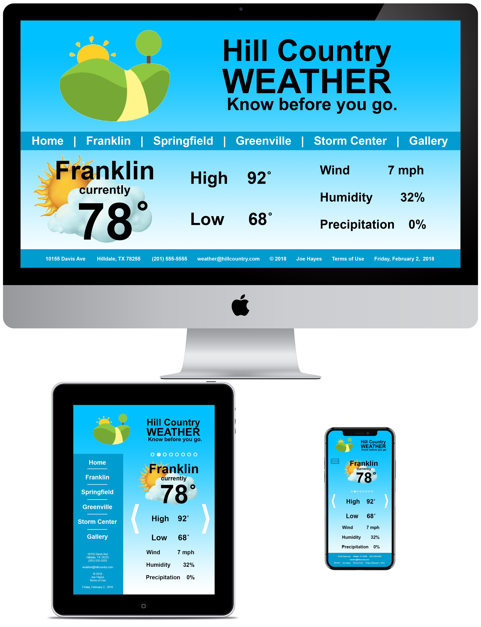**Wire-Frame Sketches**